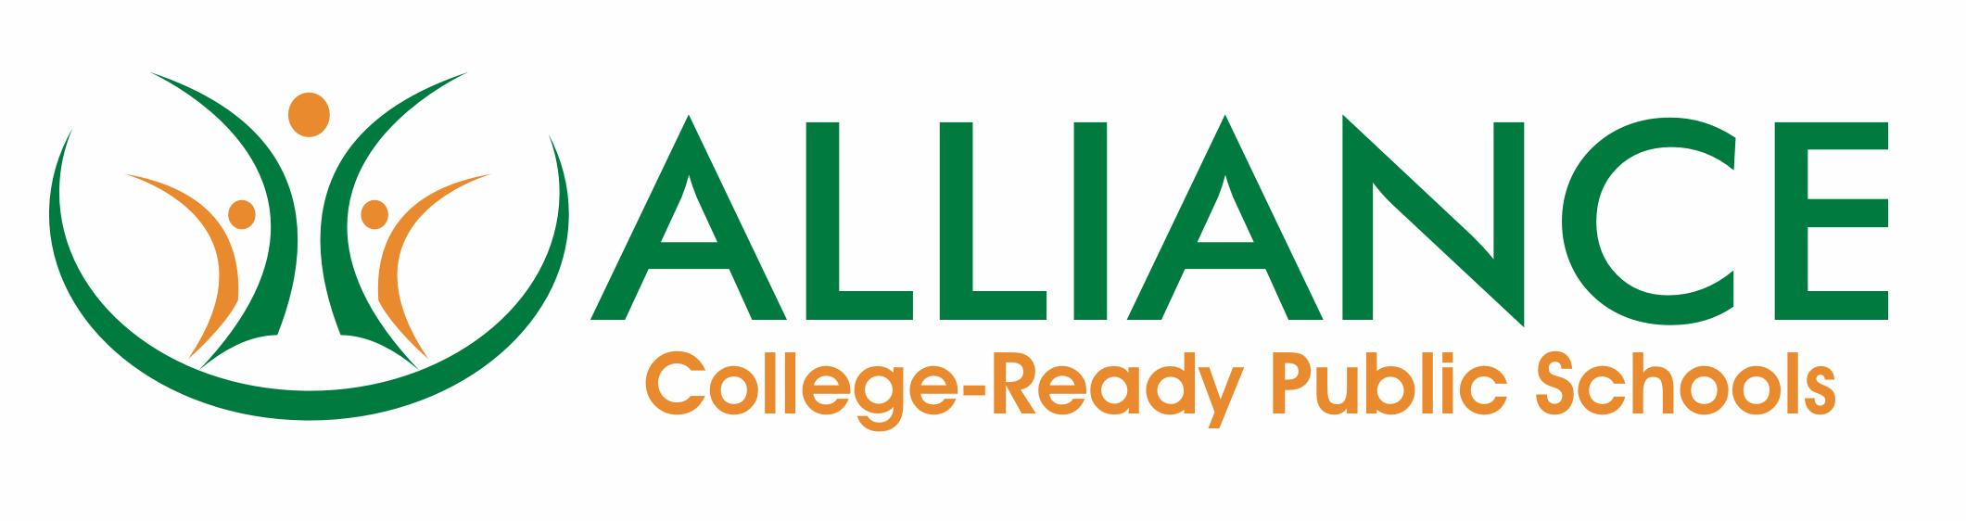

Alliance Induction Program
Vision and Goals

Alliance College-Ready Public Schools, the largest nonprofit charter organization in Los Angeles, is committed to hiring the most dedicated, qualified, and talented faculty to serve our diverse student population. To support this commitment, the Alliance partners with the Los Angeles Unified School District to offer Beginning Teacher Support and Assessment (BTSA), a no-cost, state-approved induction program designed to guide participating teachers through job-embedded formative assessment activities with an Alliance support provider.

All Alliance teachers are required to meet federal guidelines set by the 2006 No Child Left Behind Act as well as the California credentialing requirements of SB 2042 (Alpert/Mazzoni, 1998), which offers general education teachers who have a preliminary credential a formative assessment system of support and professional growth to fulfill the requirements for the California Clear Multiple Subjects, Single Subject, and Education Specialist credentials.

BTSA – Beginning Teacher Support and Assessment

BTSA offers a highly individualized approach where teachers select their own area of inquiry based on an analysis of the needs of the students in their classrooms along with an analysis of their own preparation to effectively meet those needs. The FACT program, Formative Assessment for California Teachers, is the basis of BTSA. Upon successful completion of the requirements of FACT, candidates will be recommended for completion of the induction requirements for their California Clear Teaching Credential.

FACT program

Formative Assessment for California Teachers (FACT) is a structured series of critical thinking tasks that are completed within the context of the participating teachers’ classroom with the support and assistance of an Alliance support provider.

The FACT system contains four classroom-embedded modules based on evidence collection and ongoing self-assessment:
- Context for teaching and learning: Collecting and reviewing class, school, district, and community information.
- Assessment of teaching and learning: Linking teacher preparation program knowledge with induction standards and informal classroom observation.
- Inquiry into teaching and learning: Individualized classroom-based action research that includes formal classroom observation, detailed lesson planning, students’ pre- and post-assessment data, research, professional development, and collegial collaboration.
- Summary of teaching and learning: Reflection on teaching and professional growth.

BTSA options

There are three BTSA options: (1) Full induction; (2) Early Completion Option; and (3) Dual-Credential option.

Full induction

Full induction is the two-year program that most participating teachers will complete in order to earn their California Clear Teaching Credential. The program is divided into four one-semester modules, or “courses,” based on the California induction standards for Pedagogy and Universal Access. Each course includes advisement, face-to-face classes through the LAUSD Learning Zone, and an electronic formative assessment portfolio that is completed in the candidate’s classroom under the guidance of an Alliance support provider.

Year 1 concentrates on Pedagogy, where participating teachers grow in their ability to reflect upon, interpret, and apply student assessment data from multiple measures, plan and differentiate instruction based on the diverse learning needs of their students, and grow in their ability to create and maintain safe, well-managed classrooms that foster students’ physical, cognitive, emotional and social well-being.

Year 2 concentrates on Universal Access: Equity for All Students. Participating teachers work with their Alliance support provider to design and implement equitable and inclusive learning environments for all students, including English Language Learners and students in special population such as those who are identified for special education, students with disabilities, advanced learners, and students with a combination of special instructional needs.

Early Completion Option (ECO)

The Early Completion Option is an expedited one-year program for teachers who have two or more years of full-time teaching experience with a preliminary credential and have demonstrated exemplary practice. This program is by LAUSD application only and candidates must have the written support of their site administrator. Although this is a one-year program, participating teachers are required to create an electronic portfolio of work based on the state induction standards of Pedagogy and Universal Access.

Dual-Credential Option

The Dual-Credential Option is an expedited pathway to earn a general education California Clear Teaching Credential, but cannot be used to clear a special education credential. To participate in this program, teachers must already hold a general education Preliminary Credential and a Level II or Clear Credential Education Specialist Credential (completed within the past 5 years). Teachers in this specialized program must also have access to a general education classroom that matches the general education credential in which the formative assessment assignments can be completed.

BTSA portability

Teachers new to the Alliance who (1) have a preliminary California credential, and (2) have successfully completed Year 1 of BTSA in a CTC-approved induction program in another California school district may be eligible to begin Year 2 of their induction experience. An LAUSD specialist will review completion of the prior program and make this determination. Teachers who successfully complete Year 1 of BTSA with the Alliance, and who move to another school district in California, may transport their BTSA documentation to another CTC-approved induction program.

